Medical Laboratory Professionals Week (April 20-26)
Social Toolkit

ACLA developed the following social media toolkit to help commemorate Medical Laboratory Professionals Week, taking place April 20-26. This annual celebration provides an important opportunity to recognize and show appreciation for the vital contributions of America’s laboratory professionals — the individuals who work every day behind the scenes to advance patient care and improve health.
This toolkit also includes co-branded content developed in collaboration with The American Society for Clinical Laboratory Science (ASCLS) and the National Independent Laboratory Association (NILA), which will be shared with their members to help amplify the collective voice of the clinical diagnostics industry.
We encourage you to share this content across your organizational and personal social media channels to join us in celebrating the dedication and expertise of laboratory professionals nationwide.
Also, we will also be sharing a special video featuring ACLA Board members throughout the week thanking America’s laboratorians for their hard work and commitment to patient care. As a reminder, additional resources on health observances and areas of diagnostic innovation are available for download on the Power of Knowing campaign landing page here.
For any questions or additional information, please contact Elyse Oveson.

Social Copy | Graphic
Happy #LabWeek to America’s laboratorians, whose expertise is vital to delivering accurate diagnoses and effective treatments. Your unwavering commitment ensures better health outcomes for all. Thank you! #ThePowerofKnowing | 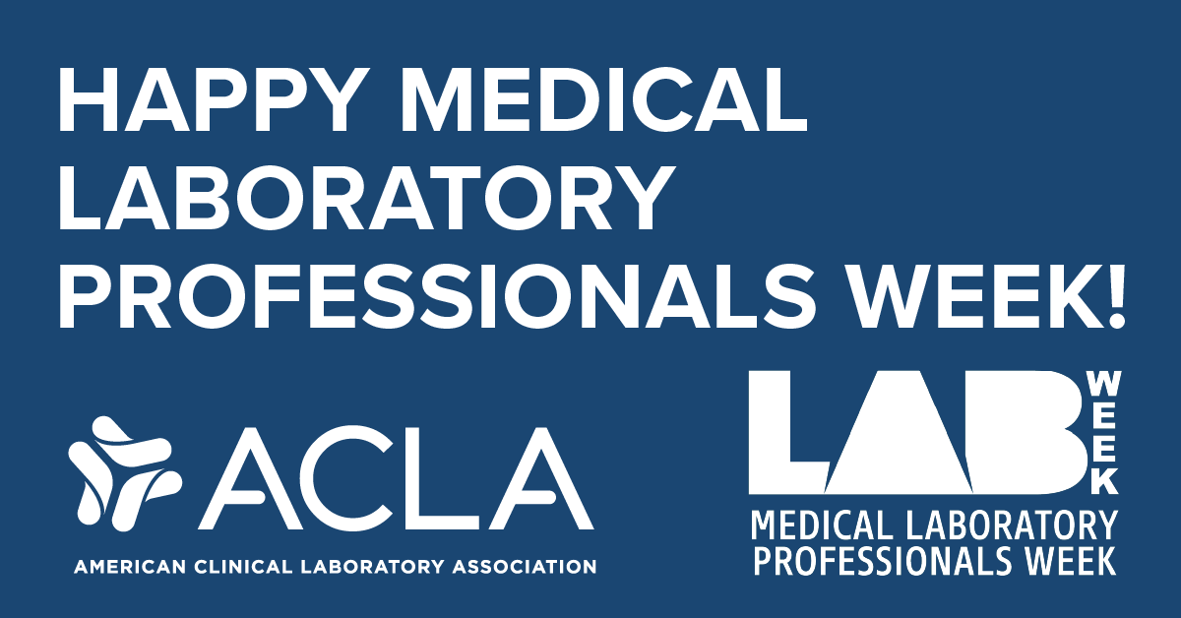
This #LabWeek, we recognize the critical role of medical laboratory professionals in clinical decision-making. Their contributions are foundational to informing care for patients everywhere. #ThePowerofKnowing | 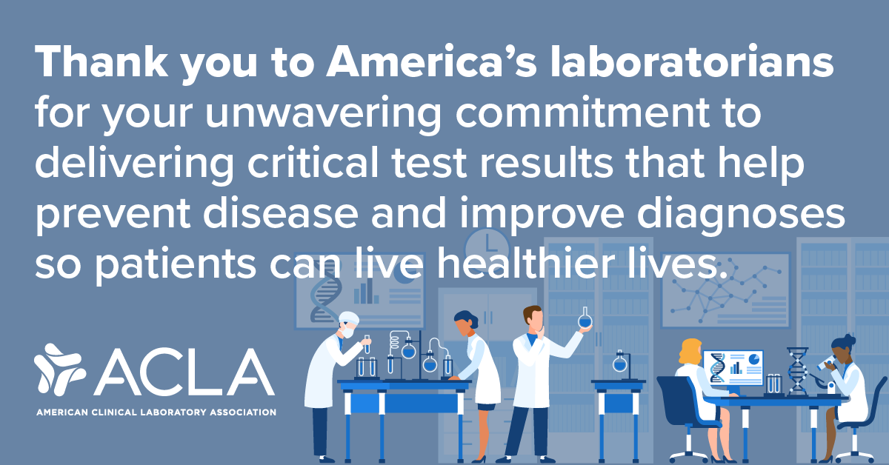
From routine tests to groundbreaking diagnostics, laboratory professionals power the health care system. We salute your precision, dedication, and hard work. #LabWeek #ThePowerofKnowing | 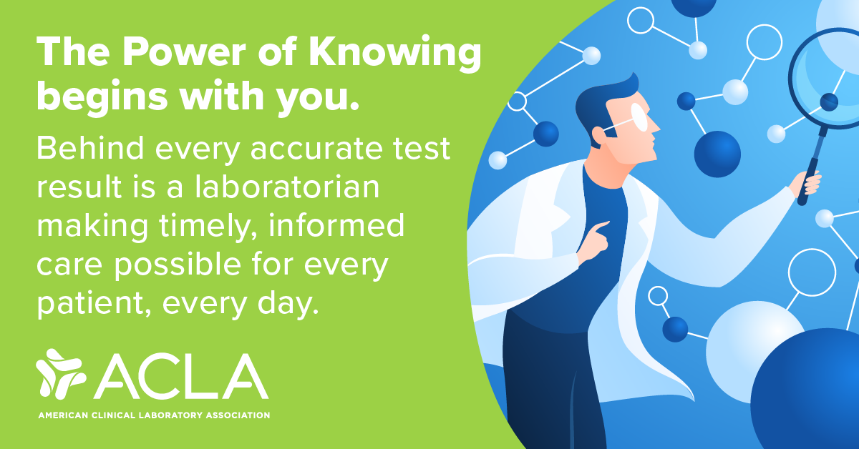
Behind every diagnosis is a dedicated laboratory professional. This #LabWeek, we honor the experts who ensure accurate and timely results for millions of patients. Your work is essential to improving outcomes and reducing health care costs. Thank you for your hard work! | 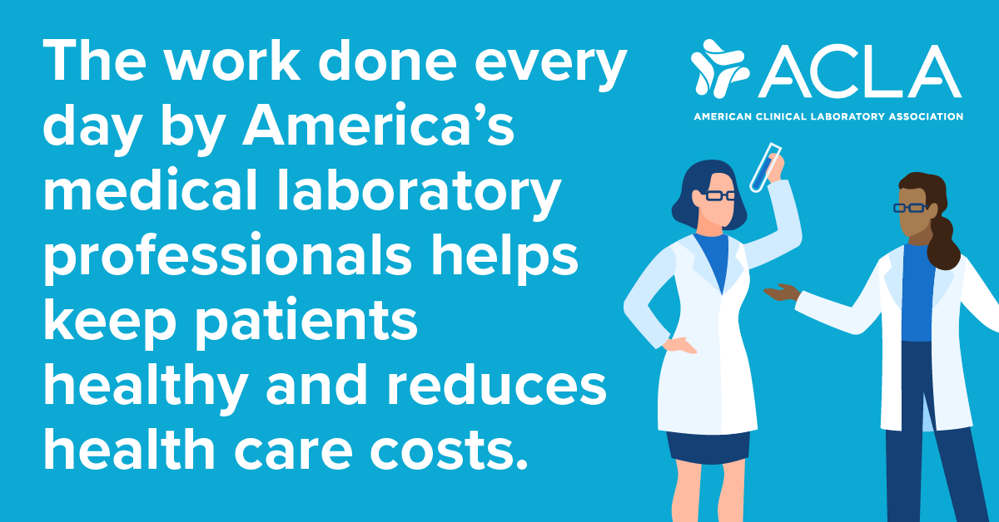
This #LabWeek, we celebrate the laboratorians who play a key role in prevention, diagnosis, and treatment of disease for millions of patients. Thank you for your daily efforts to keep patients healthy and reduce healthcare costs. | 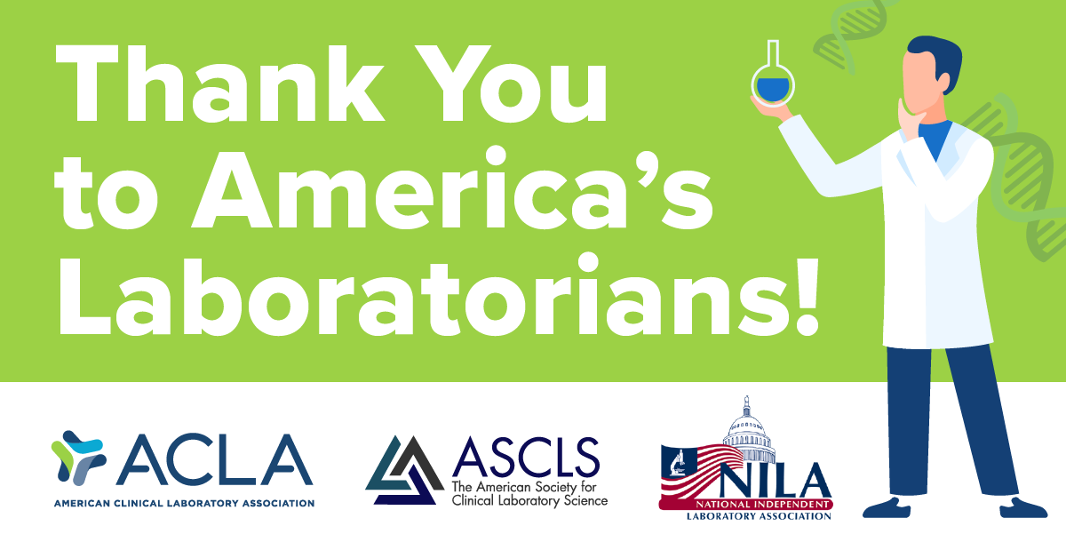
As we celebrate #LabWeek, we acknowledge the vital role of laboratory professionals in healthcare. Your hard work is instrumental in delivering accurate diagnoses and effective treatments. Thank you for all that you do for our nation’s health! | 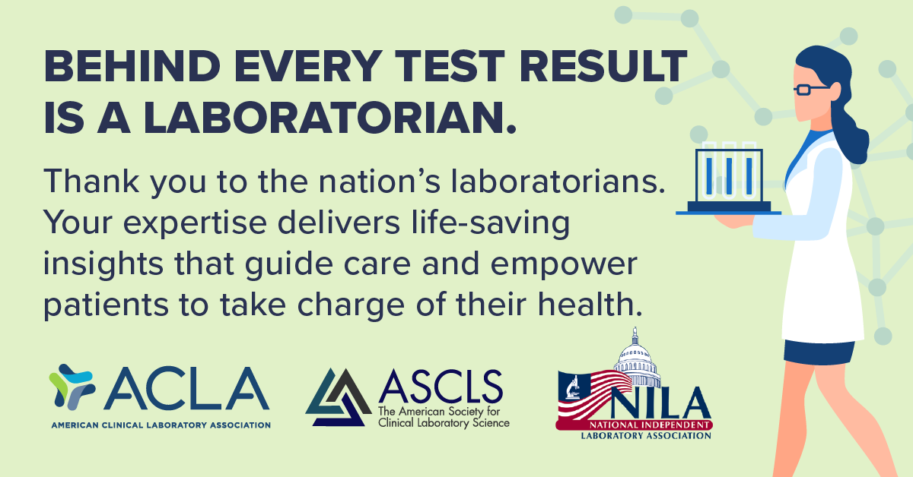
Thank you to America's laboratorians, who work tirelessly to provide life-saving diagnostics that inform treatment and care while lowering health care costs. #LabWeek | 